**TERM- Maternal Health Plan**

Mercedes Morales-Aleman, PhD

Lilanta Joy Bradley, PhD

Overall, *TERM* is based on the idea that engaged, knowledgeable, and empowered mothers have better access to pregnancy care, which is the key to better health outcomes for the entire family. The programaddresses risk factors at the base of maternal and infant health disparities through a **shared decision making model** as the foundation for a **home visit/remote pregnancy monitoring intervention** [7]. **By focusing on 2 major actionable leverage points (increasing access to care through home visits and increasing women’s knowledge and self-efficacy to manage her pregnancy and navigate the healthcare system) TERM seeks to empower mothers to take charge of their health, and increase their chances of having a safe and healthy pregnancy and infant.**

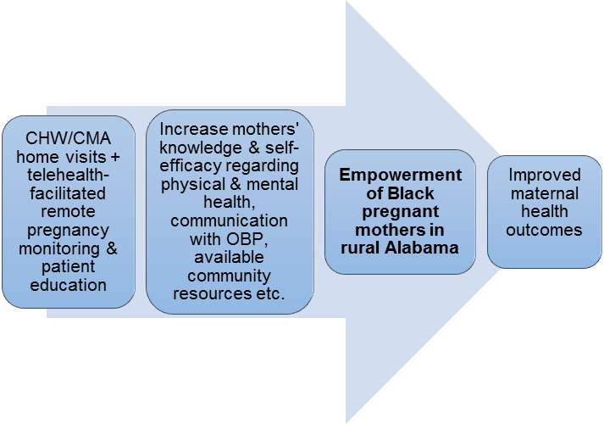

**Figure 1. TERM conceptual model**

Women recruited into the TERM program will begin their time as “TERM moms” by receiving a home visit from the nurse. At this first home visit her nurse will: (1) Meet and start establishing rapport with the mom and members of her social support network; (2) Through an mHealth facilitated process, complete health and psychosocial assessments that would be used to set the parameters for her Maternal Health Plan (MHP) goals throughout the pregnancy; and (3) Jointly develop a MHP, tailored to the mom and her family’s needs. This plan would be integrated into her EHR to facilitate communication and care coordination between the mother, nurse, OBP, and any other specialists. To date, the MHP has been completed as a word document that is saved after each home visit and uploaded to the patient’s EMR chart and shared with the patient via the Patient Portal.

We would like Dr. Crawford’s capstone design class to help develop the Maternal Health Plan into an “patient-facing” app that has the capacity to also be “provider-facing” via a webpage or software that could potentially also talk to the patient’s EMR. There are two potential components to digitalizing the MHP: patient education and health monitoring. Through patient education, the patient could receive relevant information in accordance with her identified goals, as well as pregnancy milestones that coincide with her pregnancy. Through health monitoring, the app can track, alert, and send notifications regarding weight, blood sugars, and blood pressure that are outside of a healthy range as well as medication and appointment reminders.